Brief summary
Models predicts high temperatures (near 40°C) on the central region of South America increasing the probability of fires in the region. It is noteworthy that the satellites observed an increase in the number of fire mainly in the central/northern Argentina (compared with 02 days ago: increase of 230%) and Peru (170%), totaling 6478 outbreaks of fires in America South between 12th and 13th September. Despite the possibility of fires and advection of aerosol to Sao Paulo is expected cloudiness in southeastern Brazil decreasing throughout the day.

Site | Detection Probability
Buenos Aires, Argentina | Medium/high possibility – local or advected smoke aerosol
Bariloche, Argentina | Low possibility – local smoke aerosol (cloud cover)
La Paz, Bolivia | Medium/High possibility – local and advected smoke aerosol
São Paulo, Brazil | Low/Medium possibility of local or advected aerosol (cloud cover)
Manaus, Brazil | High possibility – local smoke aerosol
Concepcion, Chile | Low possibility – local smoke aerosol (cloud cover)
Medellín, Colombia | Low possibility – local or advected smoke aerosol

Biomass Burning hotspots between 09/12 and 09/13 and smoke area from CCATT-BRAMS model (CPTEC-INPE)
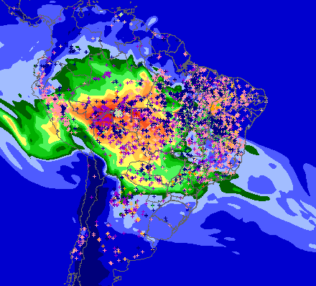
The colors represents Carbon monoxide (ppb)
MP25 from CCATT-BRAMS for 09/13 at 40m

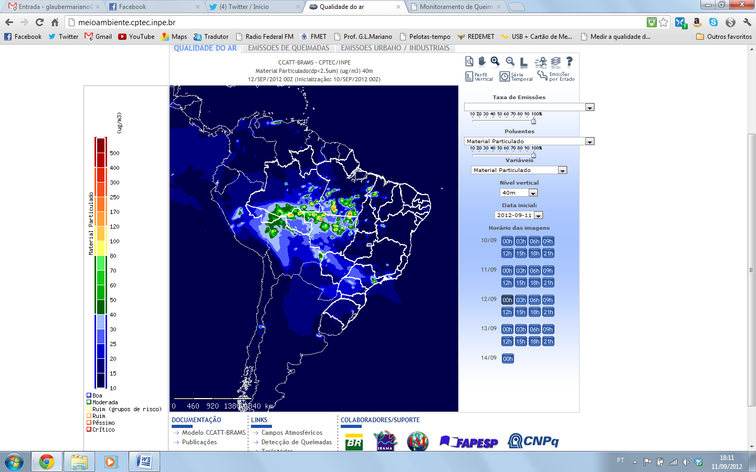 | 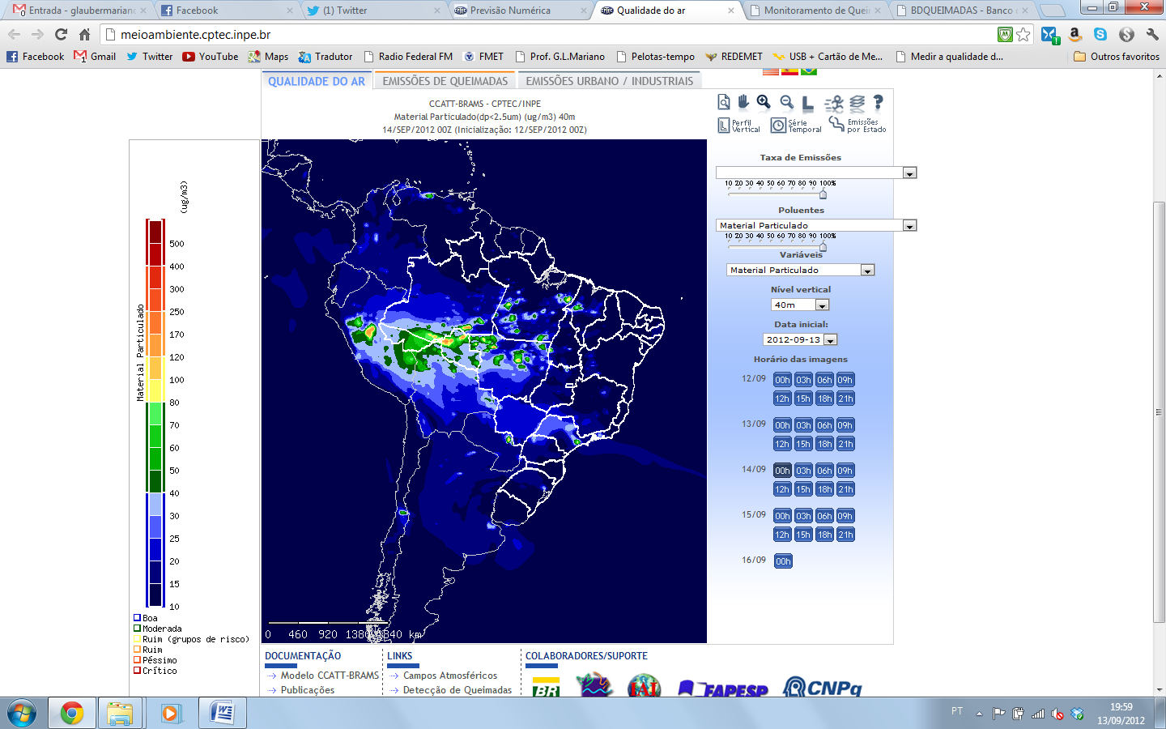 | 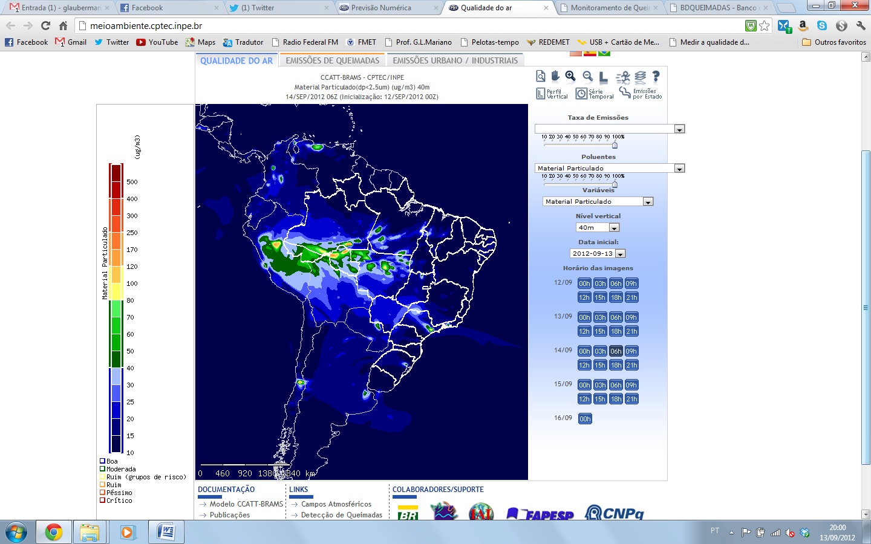
 | 00h | 06h
 | 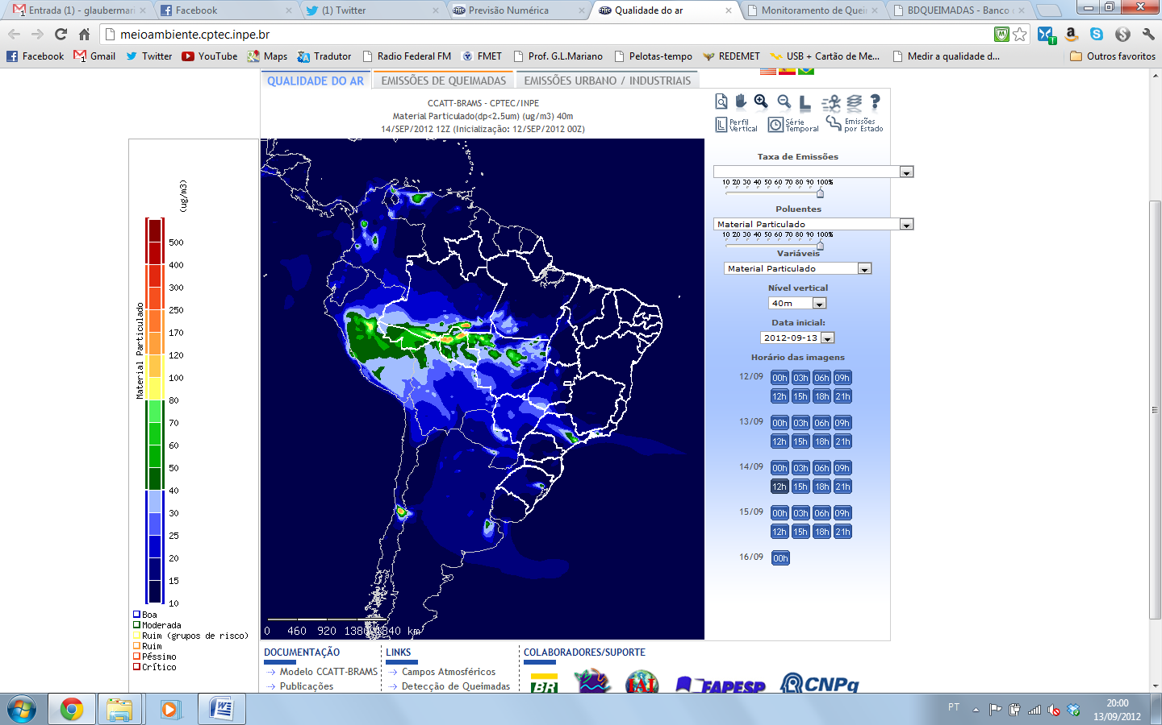 | 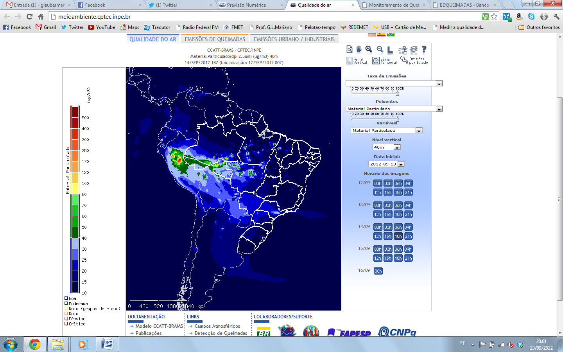
 | 12h | 18h

MP25 from CCATT-BRAMS for 09/13 at 3300m

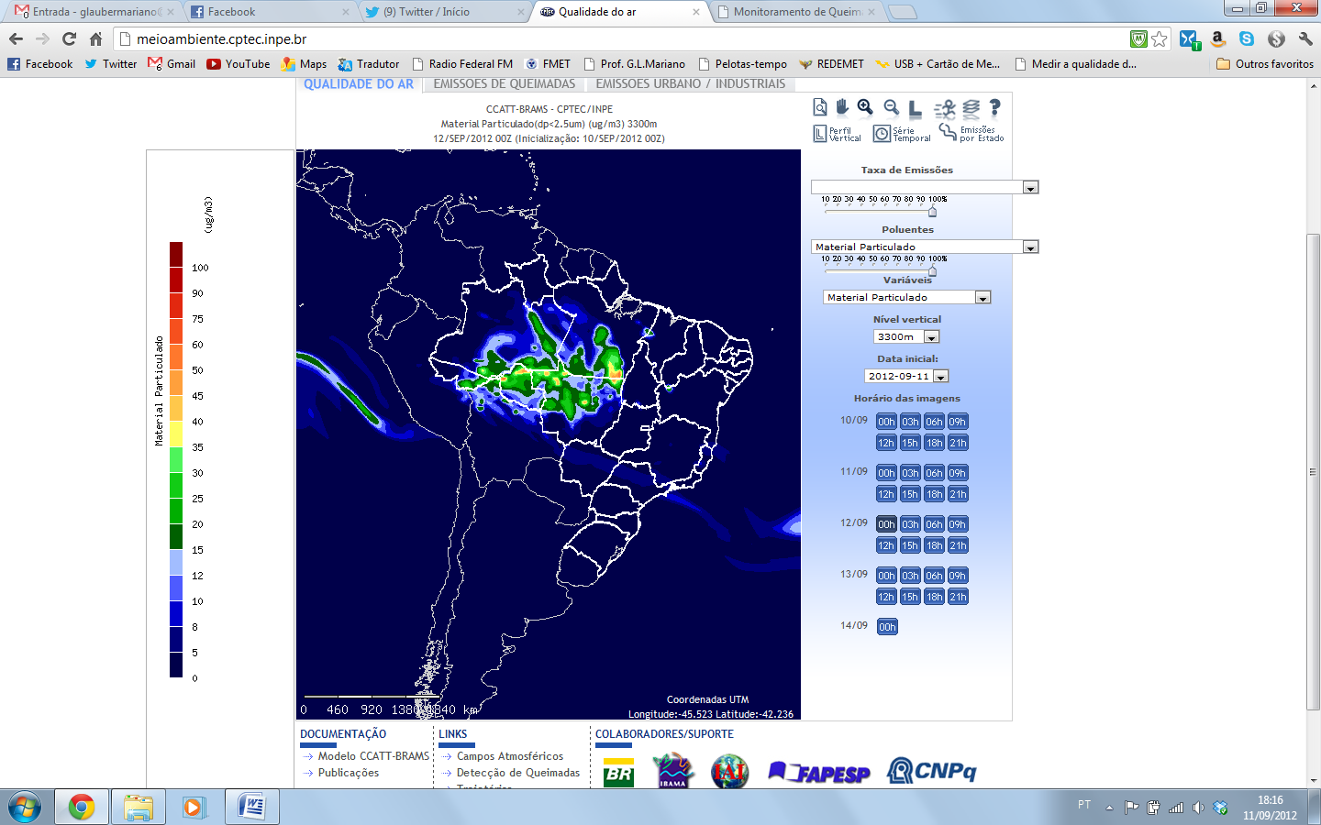 | 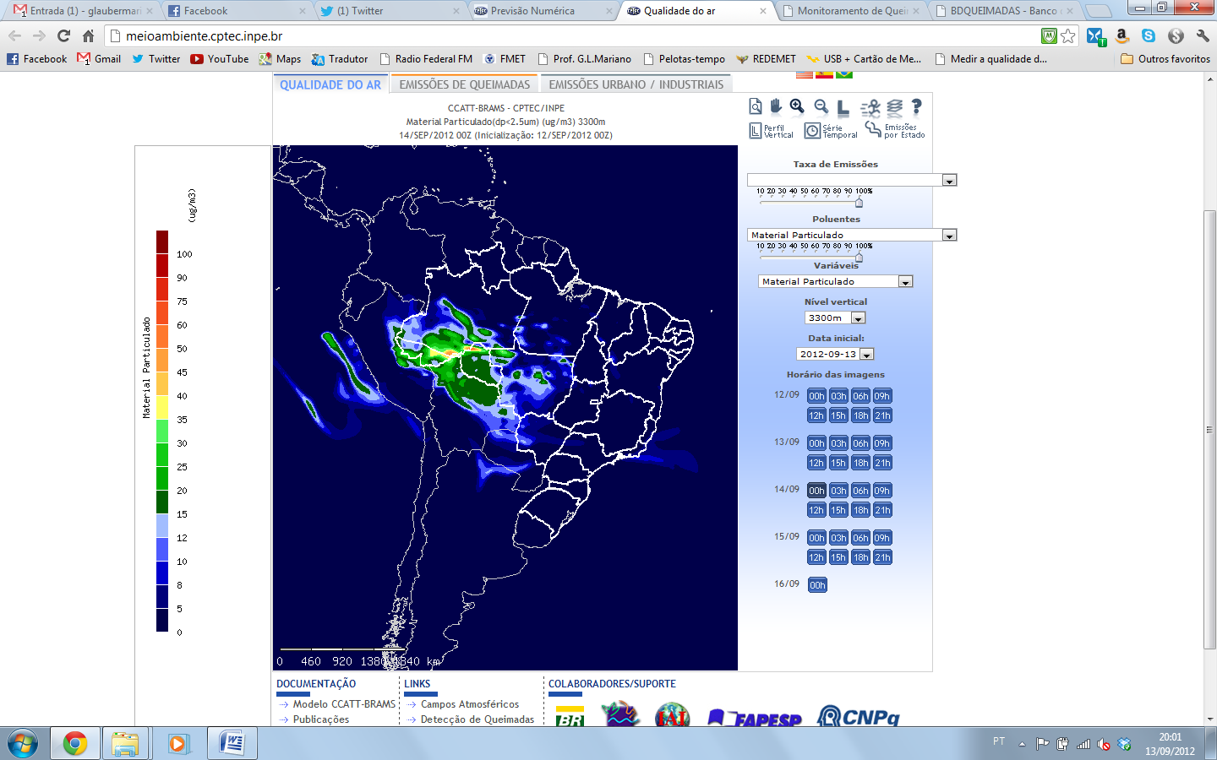 | 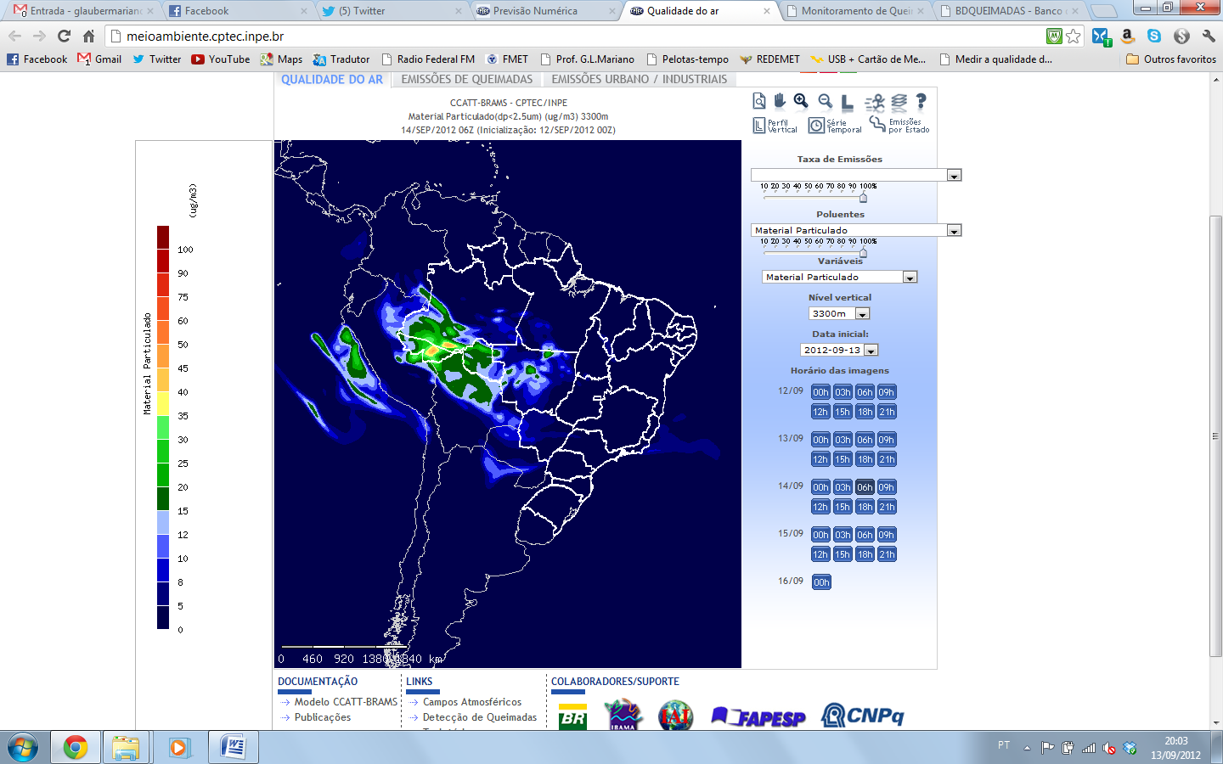
 | 00h | 06h
 | 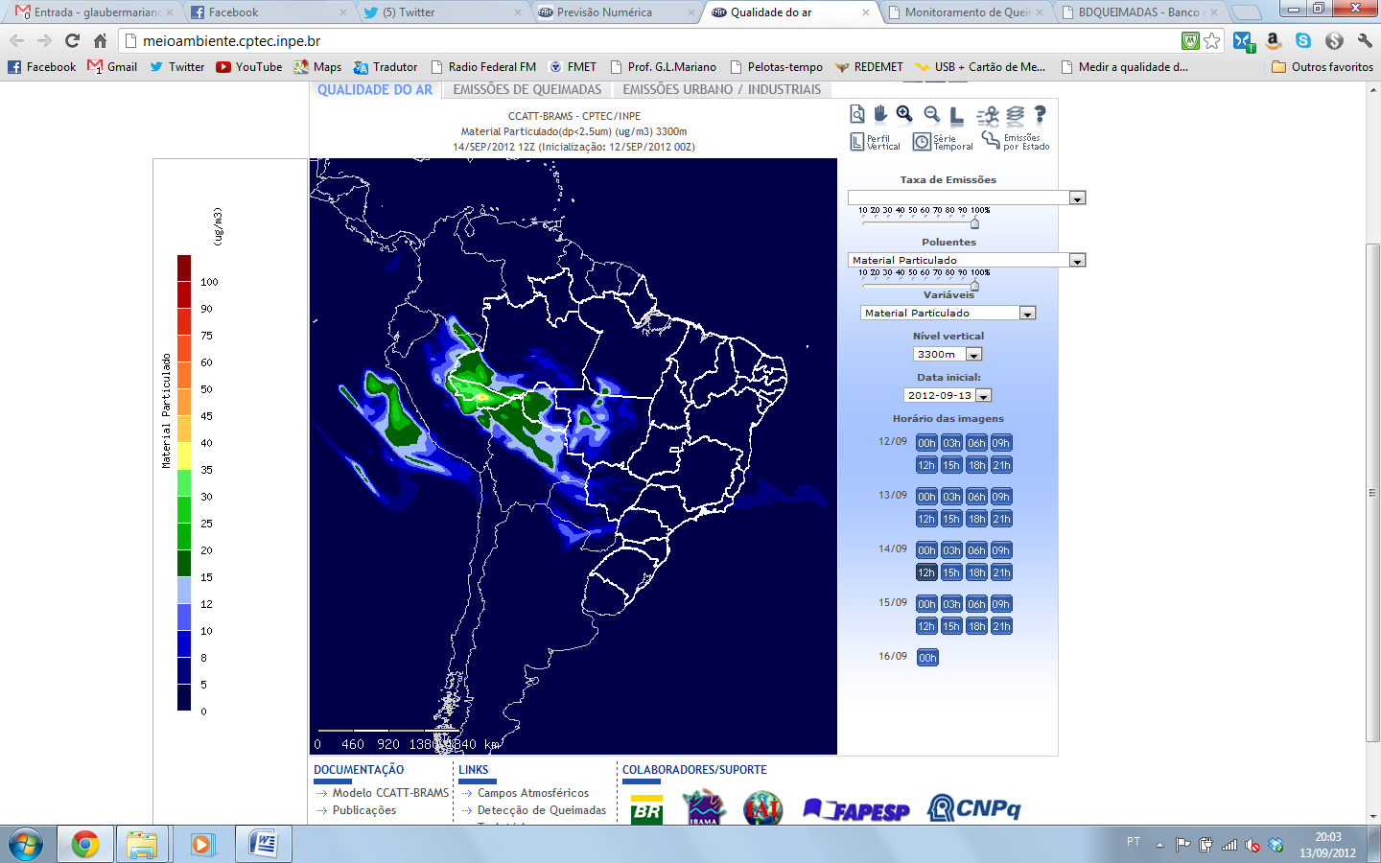 | 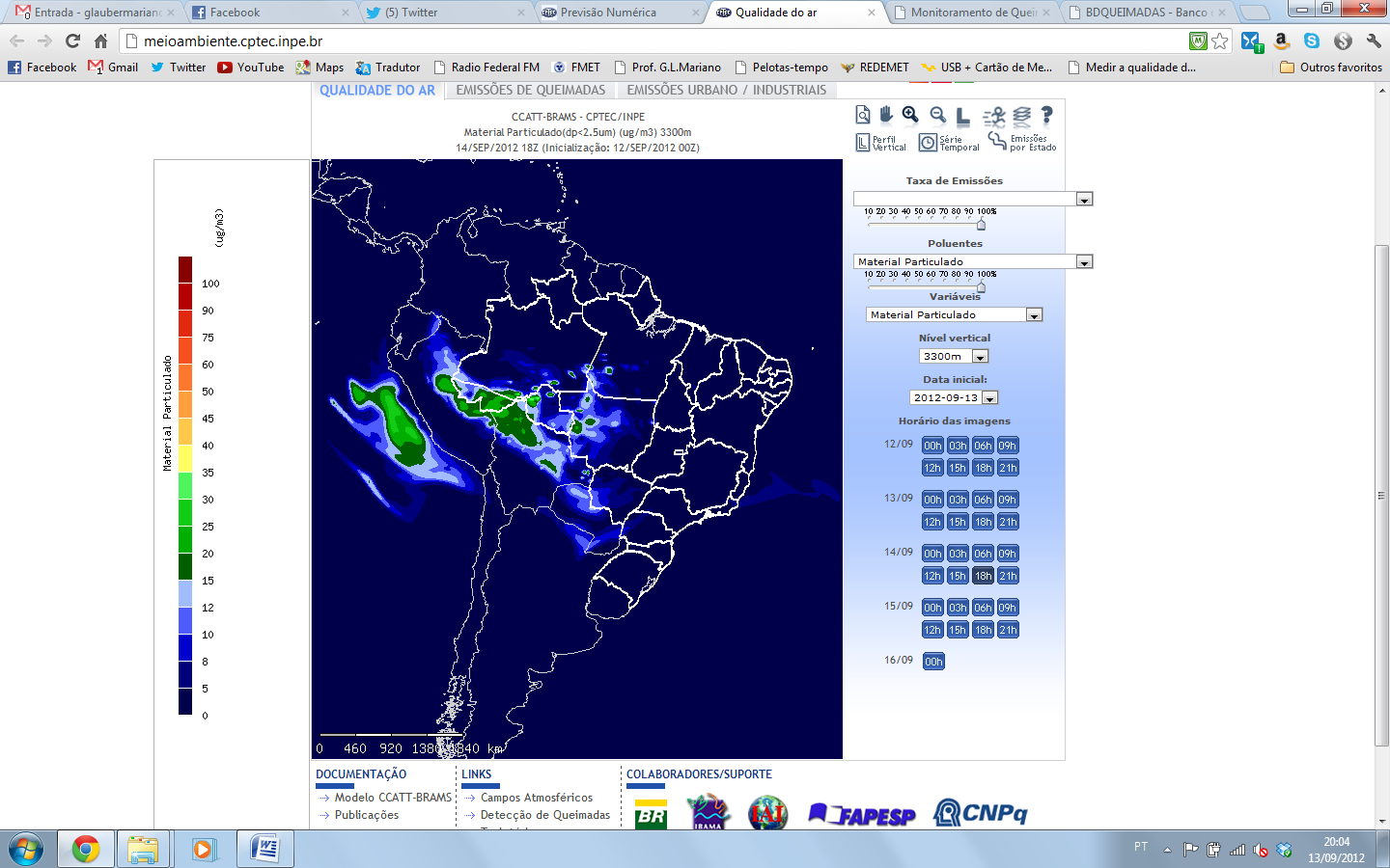
 | 12h | 18h

