Brief summary

As usual for the time of year we can see several hotspots in central South America with emphasis today in western Peru (near Brazil) and an increase in central Argentina compared with yesterday. Also worth highlight an increase in the number of fires near the location of Manaus.
As highlighted by email, Sao Paulo and Concepción was cloudy covered on 09/11. Weather models indicate the decreasing cloudiness tomorrow (mainly to São Paulo).

Site | Detection Probability
Buenos Aires, Argentina | Low possibility – local smoke aerosol
Bariloche, Argentina | Low possibility – local smoke aerosol
La Paz, Bolivia | High possibility – local and advected smoke aerosol
São Paulo, Brazil | Low possibility of transported aerosol
Manaus, Brazil | High possibility – local smoke aerosol
Concepcion, Chile | Medium possibility – local smoke aerosol (MODIS Aqua detected few fires at Chile in 09/11)
Medellín, Colombia | Medium possibility – local or advected smoke aerosol

Biomass Burning hotspots between 09/10 and 09/11 and smoke area from CCATT-BRAMS model (CPTEC-INPE)

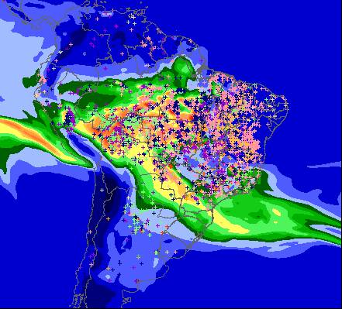
The colors represents Carbon monoxide (ppb)
MP25 from CCATT-BRAMS for 09/12 at 40m

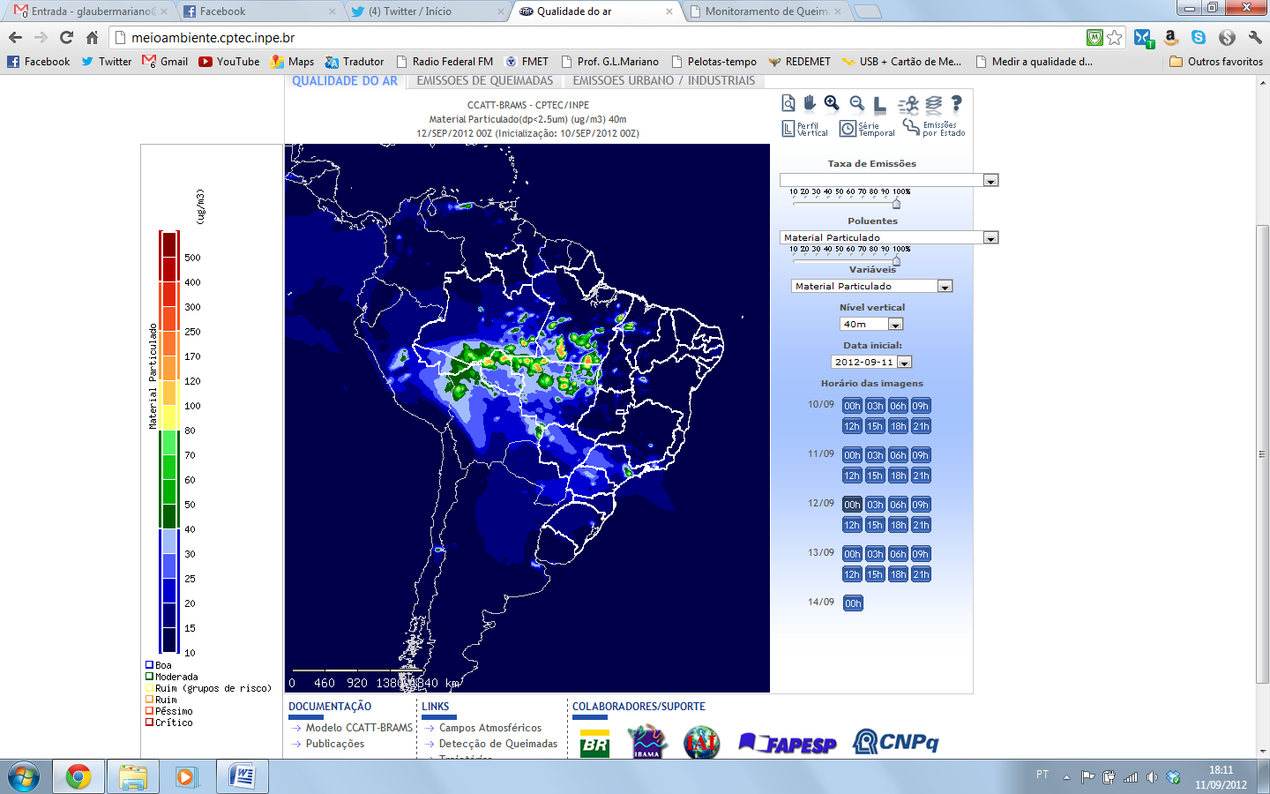 |  | 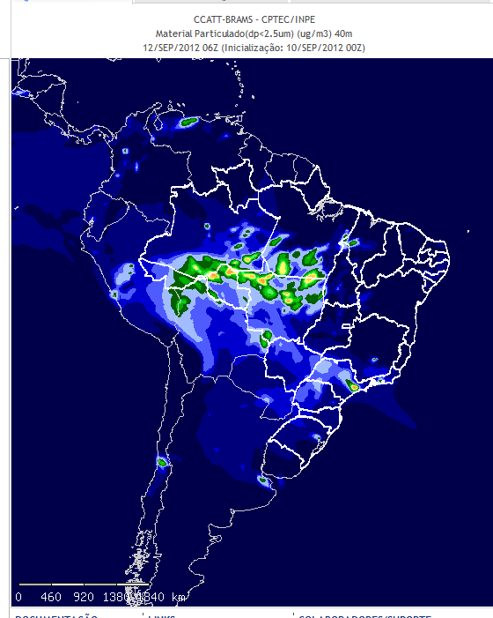
 | 00h | 06h
 | 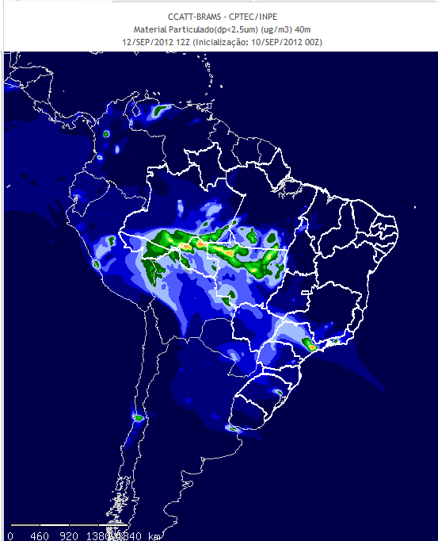 | 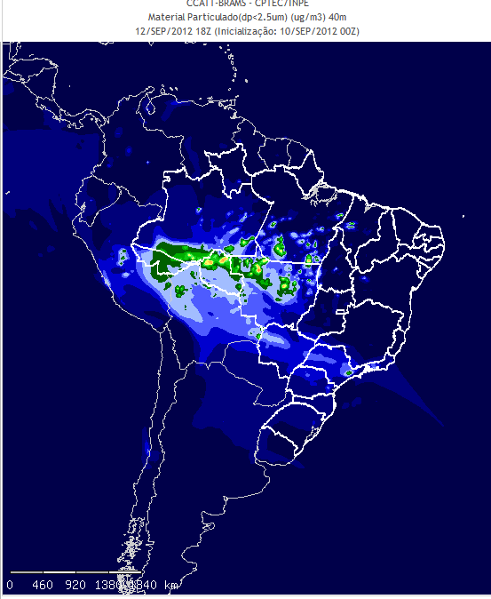
 | 12h | 18h

MP25 from CCATT-BRAMS for 09/12 at 3300m

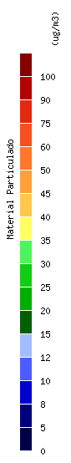 | 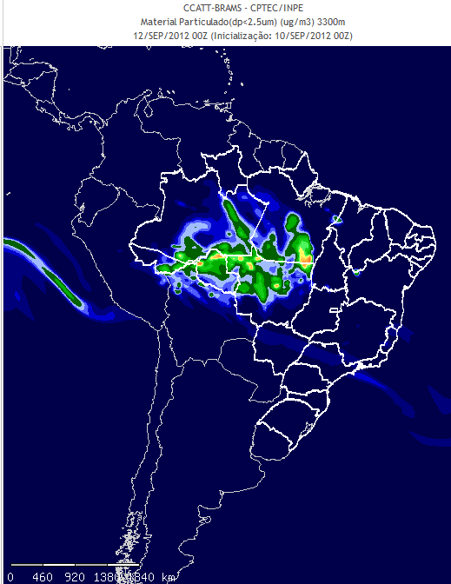 | 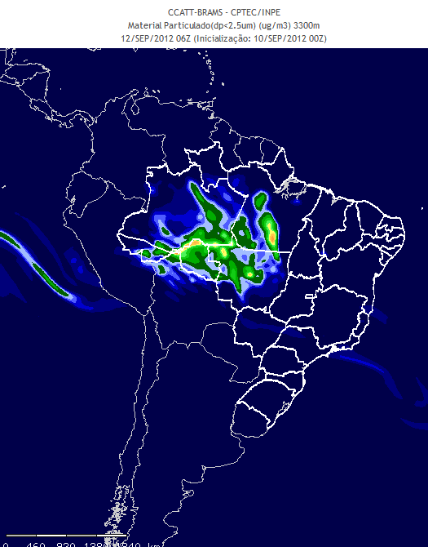
 | 00h | 06h
 | 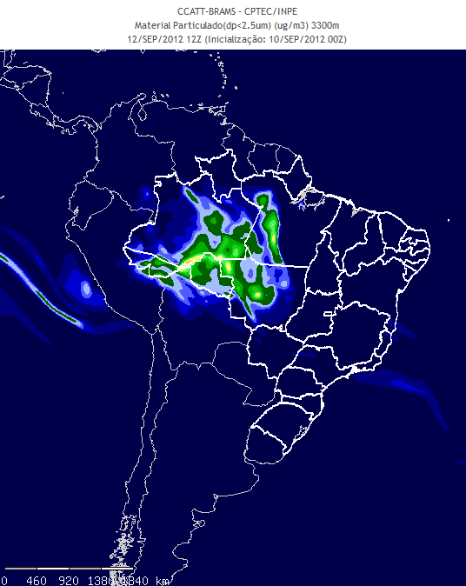 | 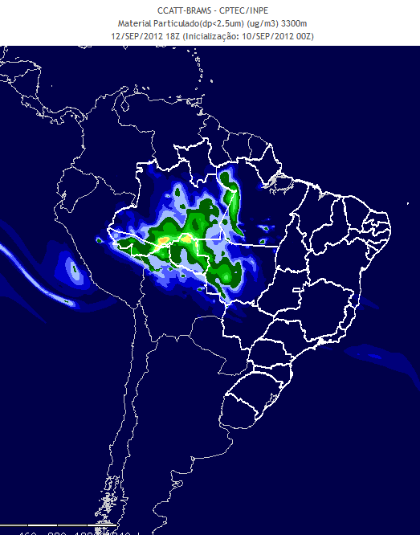
 | 12h | 18h

