Brief summary
Several biomass burning focus at the central area of South America. For September, 11th, the weather models predicts that the stationary front will remain at approximately 30°S, so that the predominant circulation northern of this region will advect the smoke plume from the central region of Brazil towards the states of Paraná and São Paulo.
Due to local outbreaks of fires detected in recent days, several sites have high probability of aerosol detection from burning focus nearby sources.

Site | Detection Probability
Buenos Aires, Argentina | High possibility – local smoke aerosol
Bariloche, Argentina | Medium possibility – local smoke aerosol
La Paz, Bolivia | High possibility – local smoke aerosol
São Paulo, Brazil | Low possibility of transported aerosol. Near source aerosol more likely
Manaus, Brazil | High possibility – local smoke aerosol
Concepcion, Chile | High possibility – local smoke aerosol
Medellín, Colombia | Medium possibility – local smoke aerosol

Biomass Burning hotspots between 09/09 and 09/10 and smoke area from CCATT-BRAMS model (CPTEC-INPE)

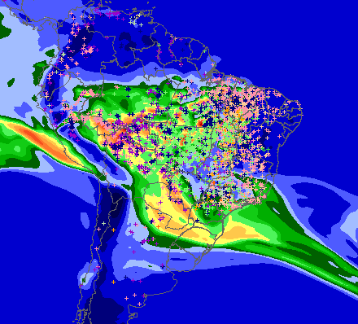

MP25 from CCATT-BRAMS for 09/11 at 40m
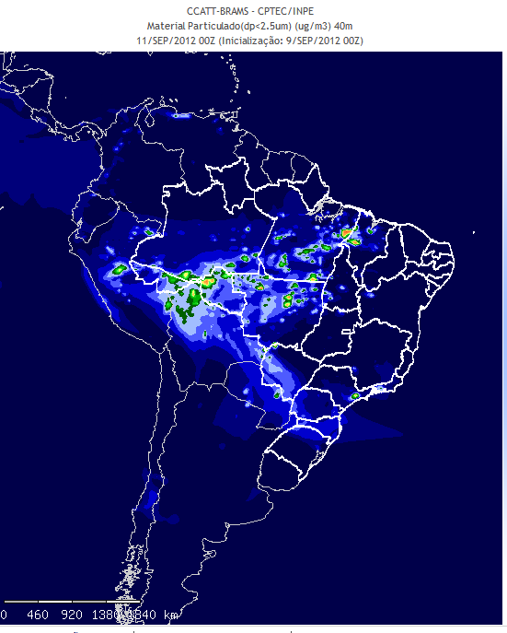 | 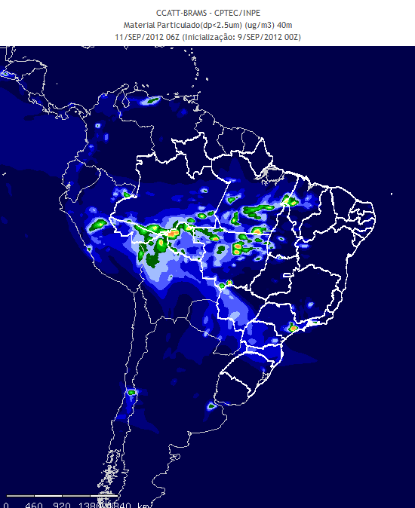
00h | 06h
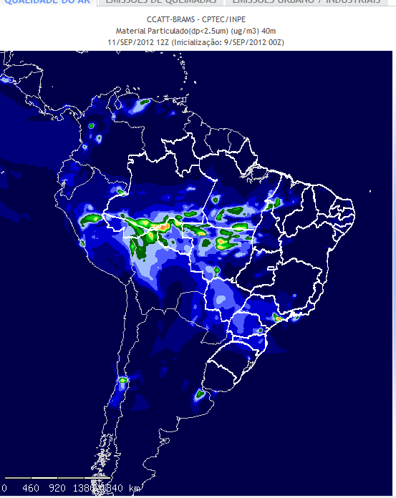 | 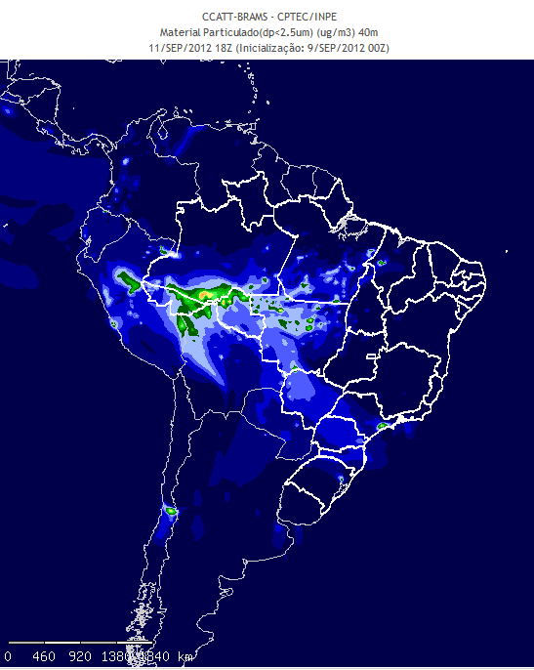
12h | 18h

MP25 from CCATT-BRAMS for 09/11 at 3300m
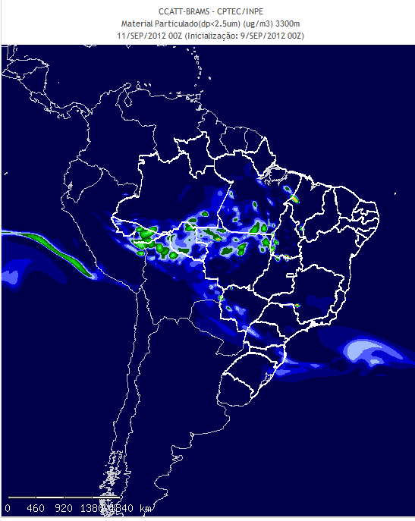 | 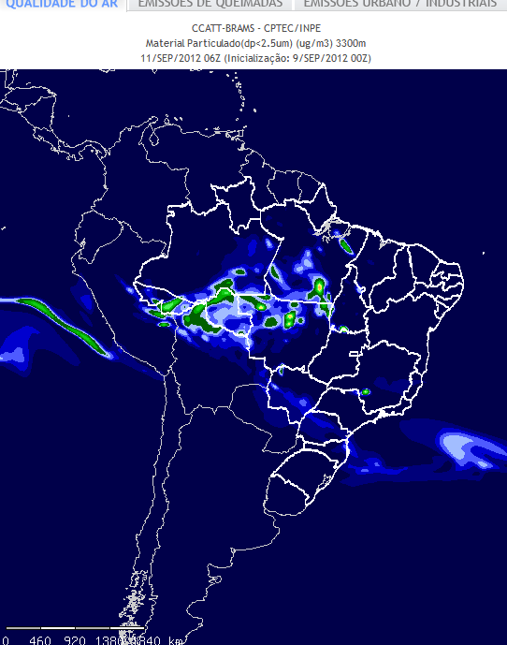
00h | 06h
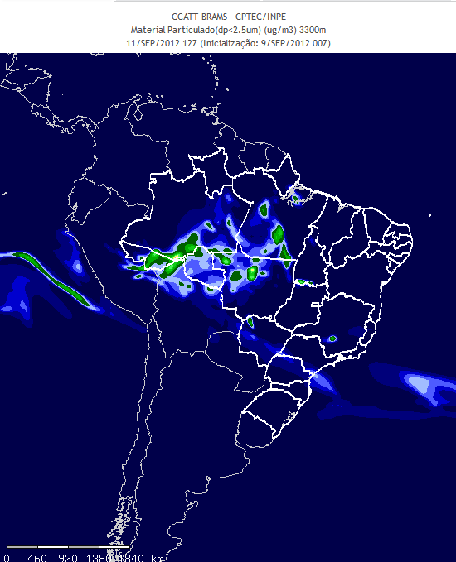 | 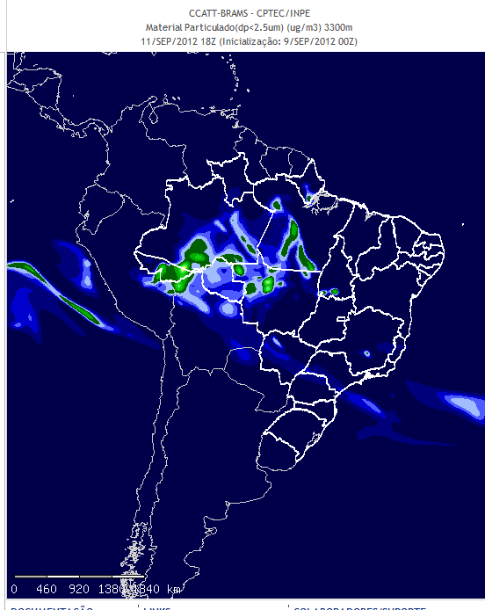
12h | 18h

